Student Management

Updating Account

Version <1.0>

Revision History

|  |  |  |  |
| --- | --- | --- | --- |
| **Date** | **Version** | **Description** | **Author** |
| <dd/mmm/yy> | <x.x> | <details> | Đào Anh Thành |
|  |  |  |  |
|  |  |  |  |
|  |  |  |  |

Table of Contents

1. Use-Case Name 3

1.1 Brief Description 3

2. Flow of Events 3

2.1 Basic Flow 3

2.2 Alternative Flows 3

2.2.1 < First Alternative Flow > 3

2.2.2 < Second Alternative Flow > 3

3. Special Requirements 3

3.1 < First Special Requirement > 3

4. Preconditions 3

4.1 < Precondition One > 3

5. Postconditions 3

5.1 < Postcondition One > 3

6. Extension Points 3

6.1 <Name of Extension Point> 3

Update Account

# Update Account

## Brief Description

This use case defines steps of updating account’s information in the system. Administrator can easily update a new account in the database.

# Flow of Events

## Basic Flow

The system administrator selects the account’s information to modify and changes the value. The administrator updates the database management parameter that holds account information. The administrator displays the updated management parameter value and logs the change.

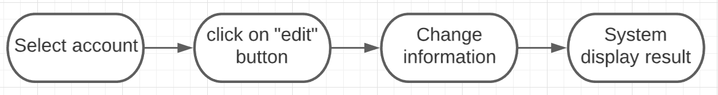

# Special Requirements

No special requirements.

# Preconditions

No preconditions.

# Postconditions

No postcondition

# Extension Points

No extension points.